Customer Sales Performance & Business Analytics Dashboard
Data Analysis with Python Internship – Task 2

1. Introduction and Objective
Task 2 extends the basic Python and EDA work from Task 1 into advanced data wrangling. The goal is to connect customer, product and sales information, prepare the data for analysis, create business features and present the results in a dashboard and reports.

2. Dataset and Source
A public retail sales dataset was used. The working sample contains 251 transaction rows with transaction date, customer ID, gender, age, product category, quantity, price per unit and total amount. The source is synthetic and is used here for internship practice.
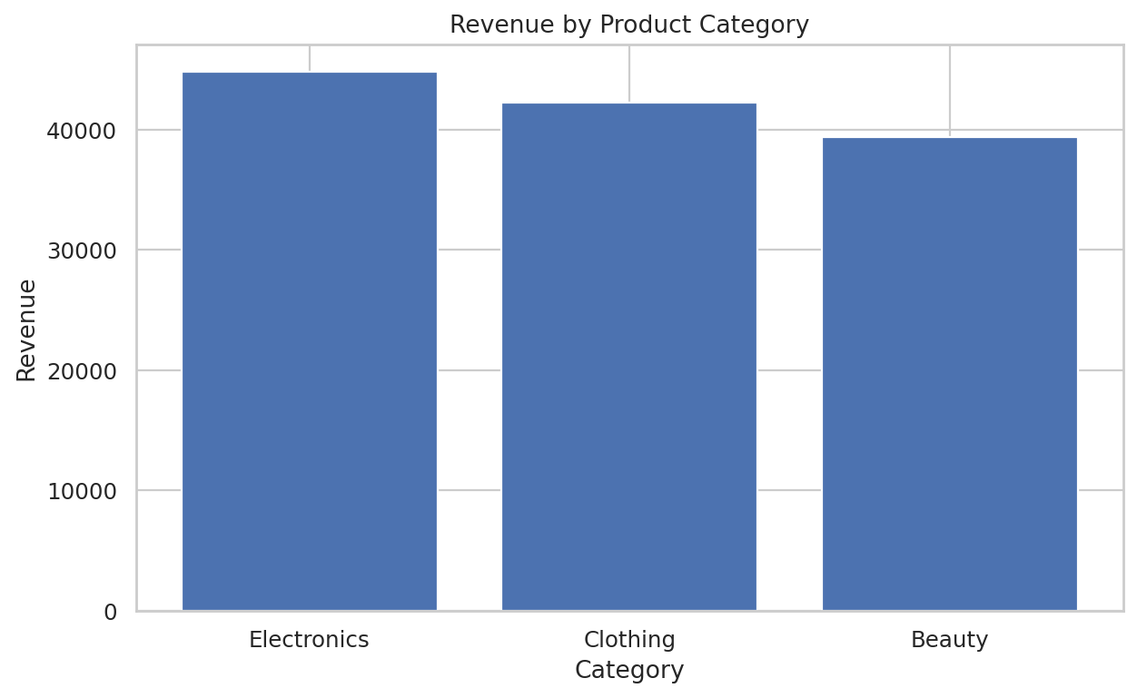

3. Data Modelling
Because the source does not provide a product ID, the project creates an analytical product key from category and unit price. The data is then organized into customer, product and sales tables. This allows merge and join operations to be demonstrated without pretending that missing source fields exist.

4. Data Cleaning and Validation
Column names and data types are standardized. Duplicate rows and missing values are checked. Revenue is recalculated as quantity multiplied by unit price and compared with the source total amount. The raw sample is preserved separately from processed outputs.
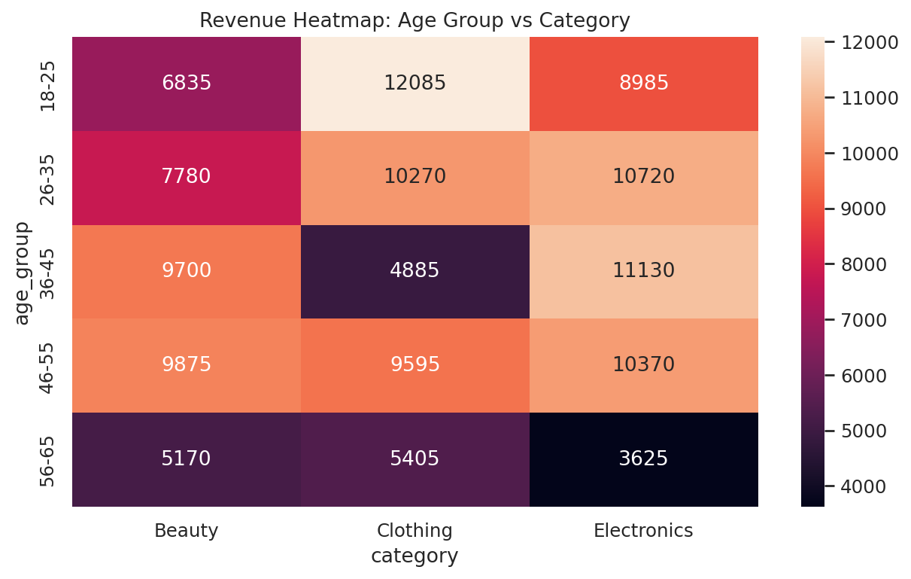

5. Advanced Pandas
The project uses merge operations to combine sales with customer and product information. GroupBy creates category, monthly and customer summaries. A pivot table compares age groups with category revenue, and a cross-tab compares gender with category.

6. Feature Engineering
The analysis creates month, quarter, year, age group, price band and customer-value segment fields. These features make the dataset easier to group and interpret. Revenue is also recalculated and validated.

7. Business KPIs
The working sample contains 251 transactions, 251 customers and 628 units. Total recorded revenue is 126,430. The average transaction value is 503.71. Because each source customer appears once in this sample, customer ranking is not a repeat-purchase measure.
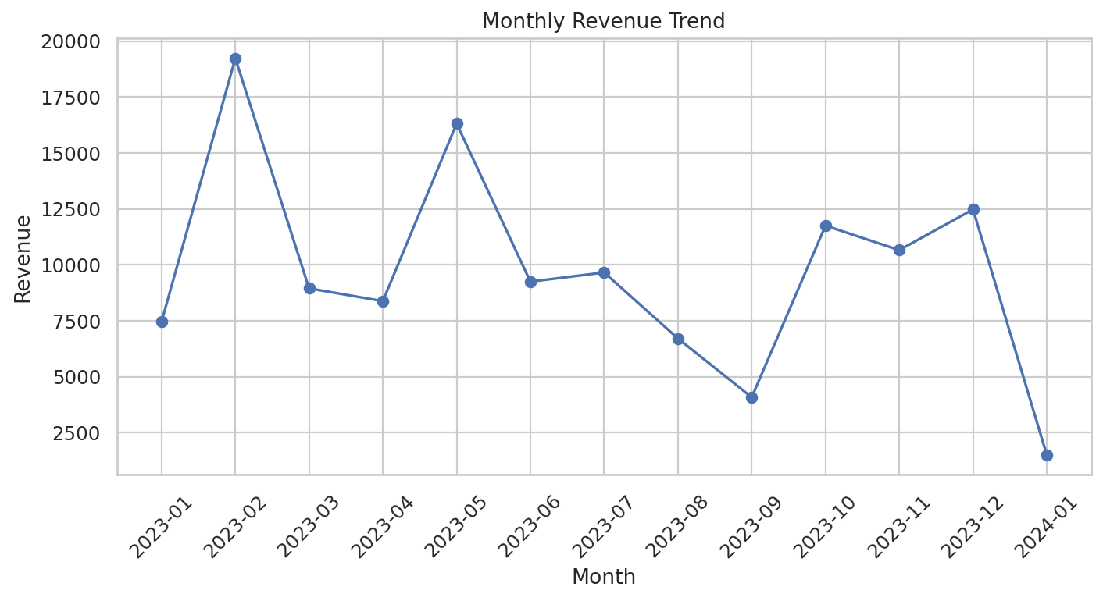

8. Visualizations
The project includes category revenue, monthly trend, gender comparison, age/category heatmap, transaction box plot, quantity versus revenue scatter plot and transaction count. Matplotlib and Seaborn are used according to the Task 2 requirements.

9. Dashboard and Reporting
The Excel report contains KPI, category, monthly, customer, pivot, cross-tab, price-band, outlier, integrated-data and quality-check sheets. The HTML dashboard provides KPI cards, category and gender filters and a top-customer table.
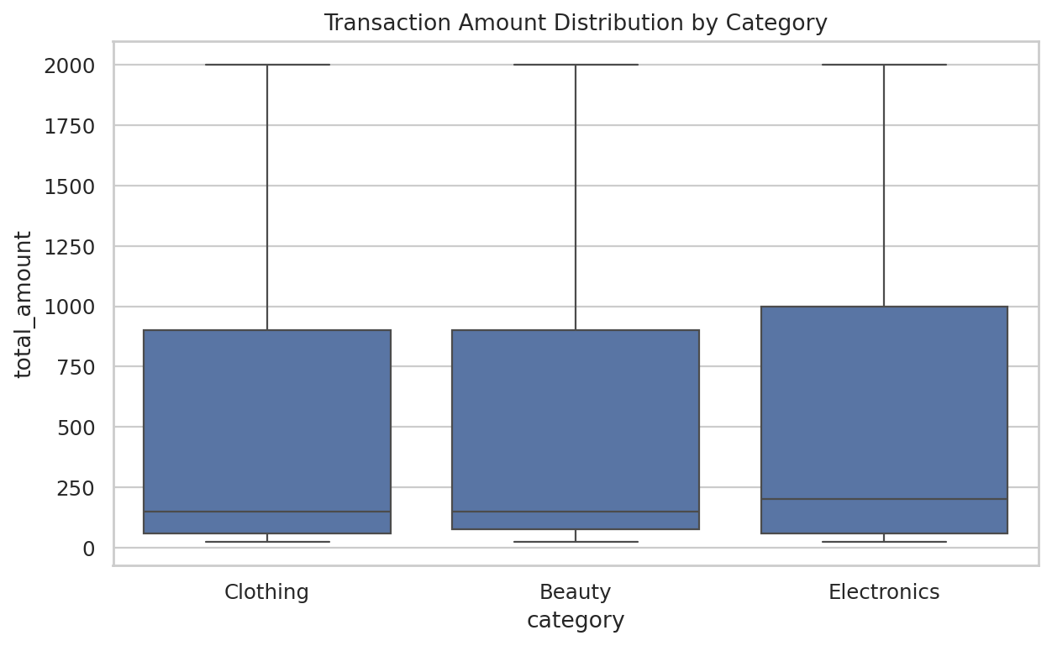

10. Limitations and Conclusion
The dataset is synthetic and the working sample is smaller than the full public file. The source has no product cost, so profit is not calculated. The engineered product key is clearly documented. The final workflow demonstrates the main Task 2 skills without hiding data limitations.

Appendix – Project Outputs
- Python source modules
- Executed Jupyter Notebook
- Integrated dataset
- Excel report
- PDF report
- HTML dashboard
- Business charts
- Screenshots
- Diagrams
- README
- Demonstration script

